# PROJECT REPORT TEMPLETE

## JOB APPLICATION TRACKING SYSTEM

1. **INTRODUCTION**

## Overview

* Stores job candidate information like resumes, cover letters, references, and other recruitment and hiring data that HR teams can easily access and organize.
* Tracks job candidates and their application status throughout the hiring pipeline.
* Weeds out unqualified candidates and recommends the best fit for a position based on the parameters set by HR. Only those on the shortlist are moved to the next stage of the hiring process.
* Automates time-consuming administrative tasks such as manually screening applicants, reading resumes, scheduling interviews, and sending notifications and emails to job candidates and employees.
  1. **PURPOSE**
* An ATS creates opportunities to automate manual processes, increase visibility into the hiring cycle for the entire recruiting team, and increase opportunities for communication throughout the candidate journey. 78% of recruiters using an ATS report that it has improved that it has improved the quality of the candidates they hire.
* One of the most significant ATS benefits is organization; the system ensures that no follow – up email or interview appointment is forgotten and helps create a replicable routine around fulfilling hiring needs.
* Social networks are essential to the recruiting progress, an ATS will be more fully integrated with social media to identify top – end passive and active candidates while also helping organizations build a strong social brand.

## Problem Definition & Design Thinking

* 1. **Empathy Map**

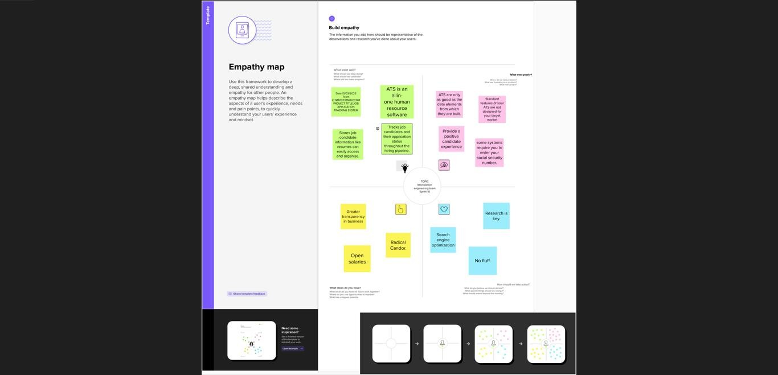

## Ideation & Brainstorming Map

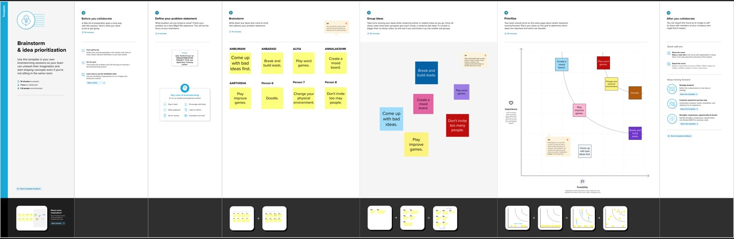

1. **RESULT**

## Data Model:

|  |  |
| --- | --- |
|  |  |
|  |  |
|  |  |

|  |  |  |  |  |
| --- | --- | --- | --- | --- |
| **Object name** | **Fields in the Object** | | | |
| **Obj1** | Field label Data type Recruiter Auto Number | | | |
| **Obj2** |  | | | |
|  | Field Label | Data type |  |
| Job | Text |  |
| Candidate | Text |  |
| Job application | Text |  |
| Tab | Text |  |

* 1. **ACTIVITY & SCREENSHOT MILE STONE – 1 SALES FORCE**

## ACTIVITY - 1

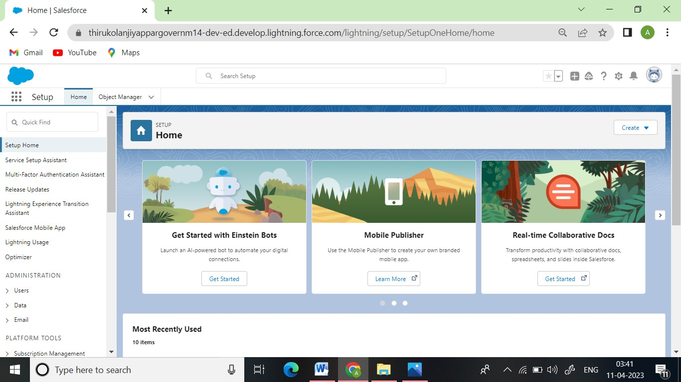

**MILE STONE – 2 OBJECT**

## ACTIVITY – 1

**Recruiter**

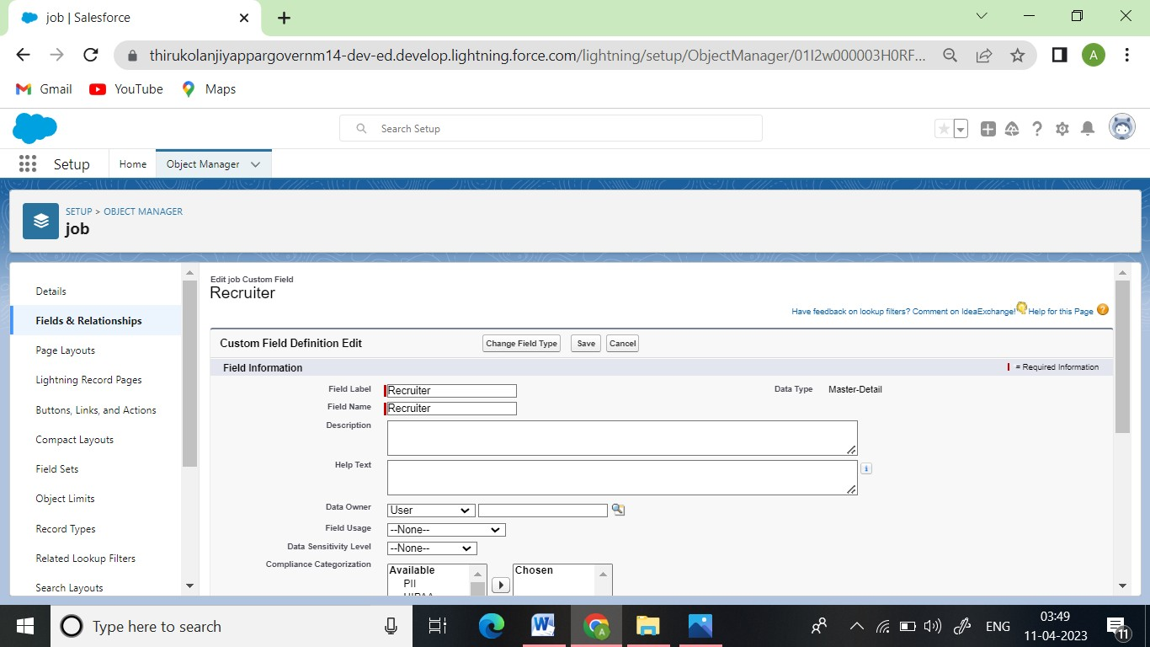

## ACTIVITY – 2

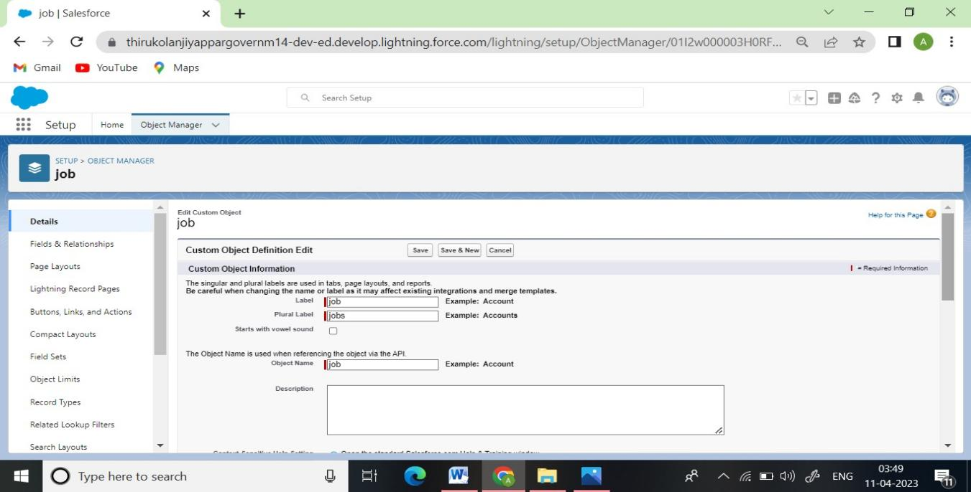**Job**

## Candidate

**Tab**

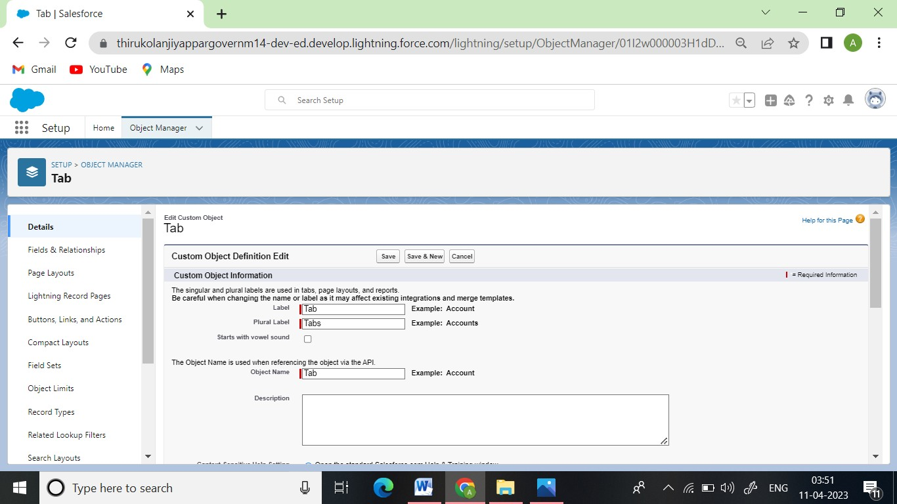

## MILESTONE 3 – FIELDS:

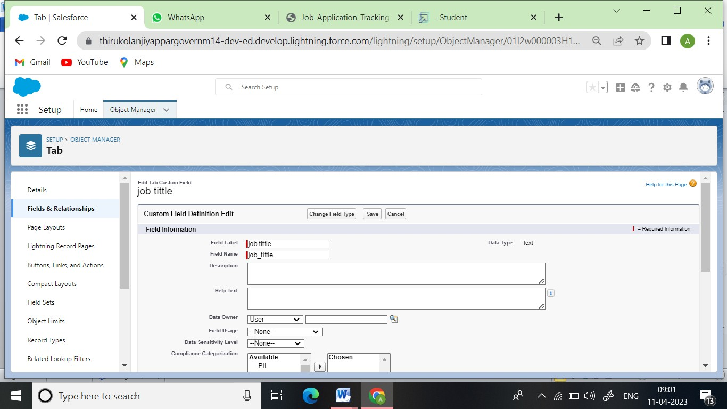**Activity 1:** Create the custom fields

## Activity 2:

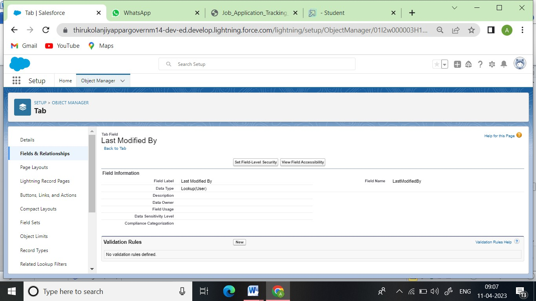

**Activity 3:**

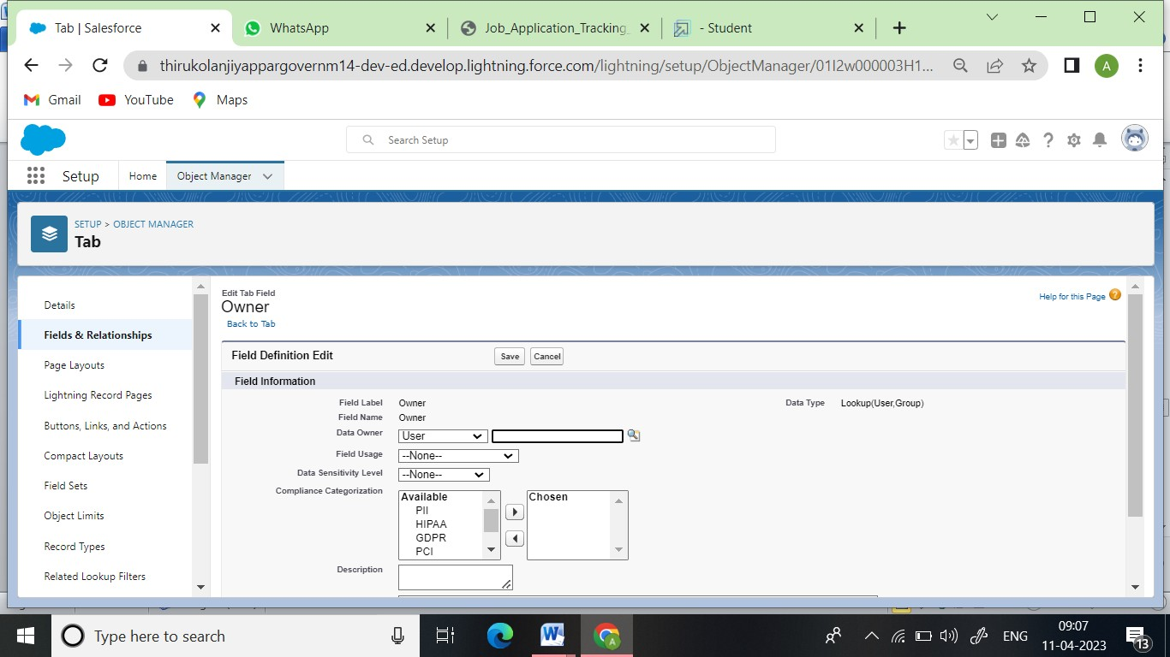

## Activity 4:

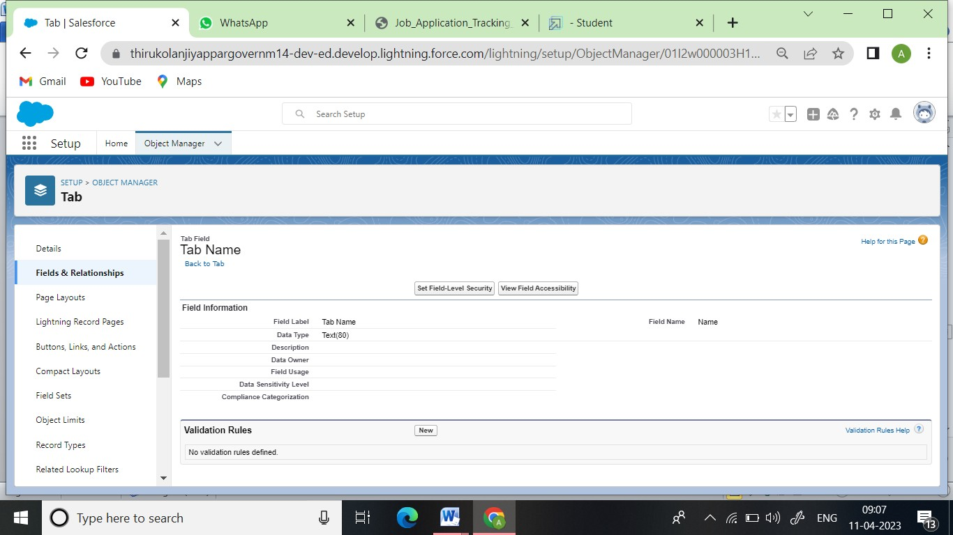

**MILESTONE 4: TAB**

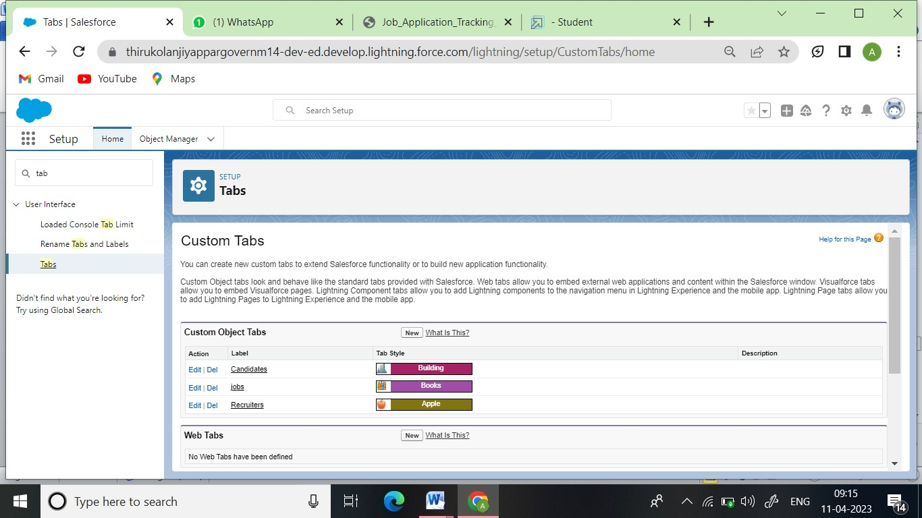

## MILESTONE : 5 PROFILE

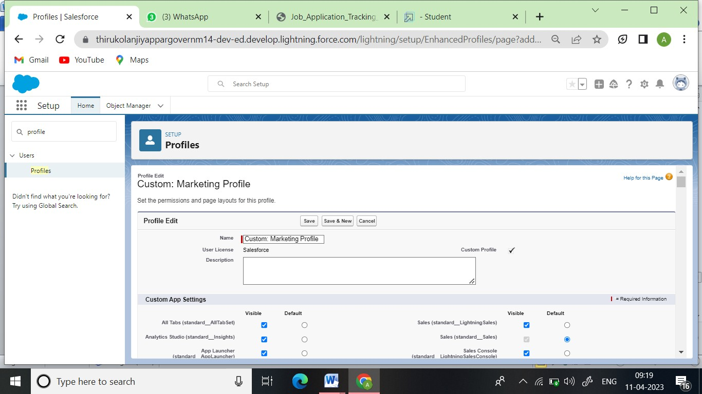**Activity - 1**

## Activity -2

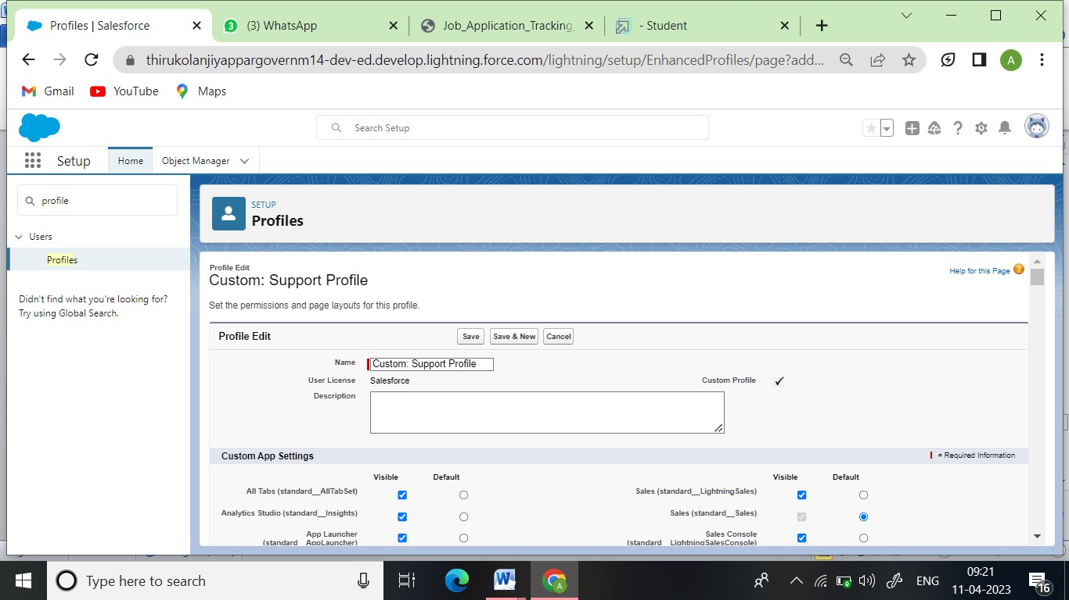

**MILESTONE – 6 USER**

## Activity - 1

**Activity – 2**

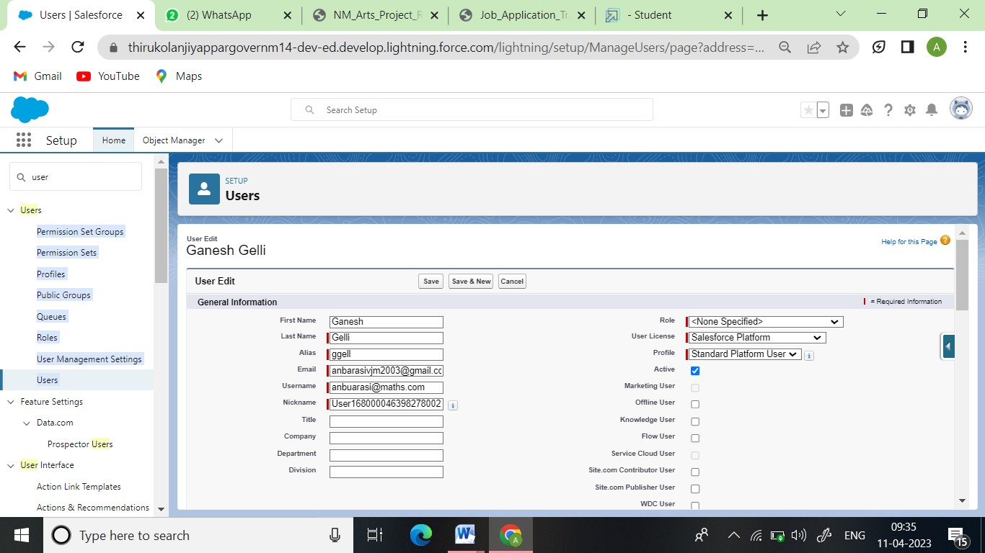

## MILESTONE – 7 SHARING RULES

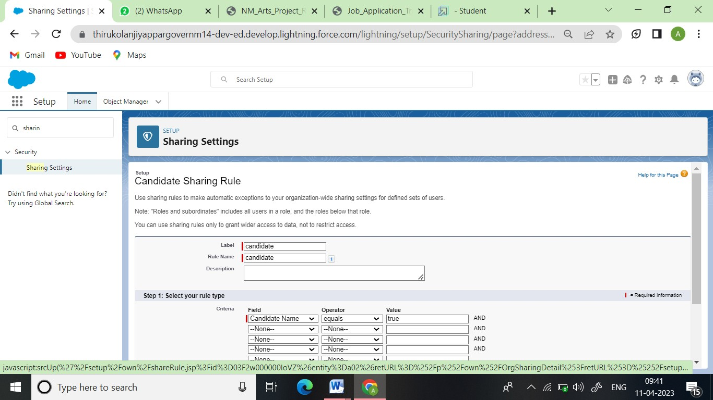**Activity - 1**

## Activity – 2

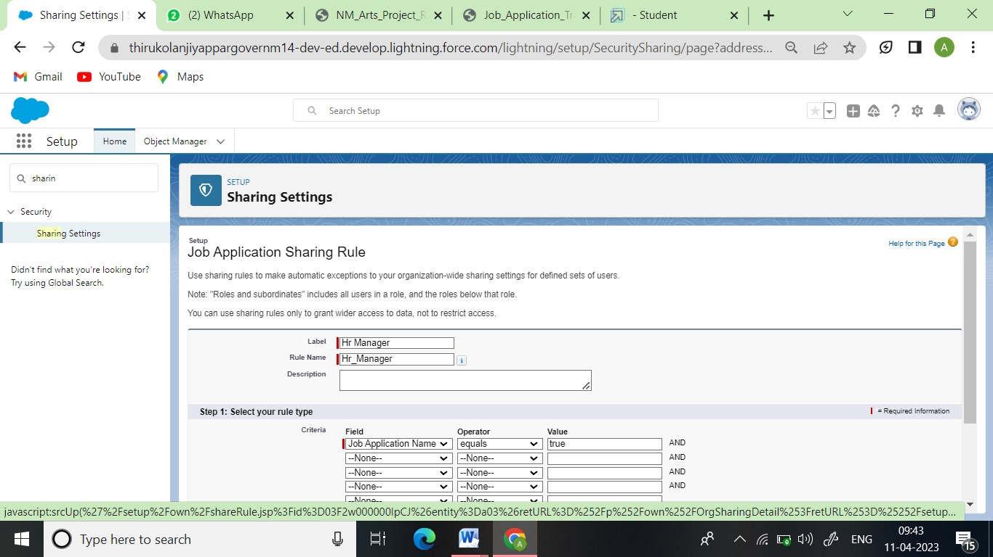

**MILESTONE – 8 REPORTS**

## Activity – 1

**Activity – 2 Job**

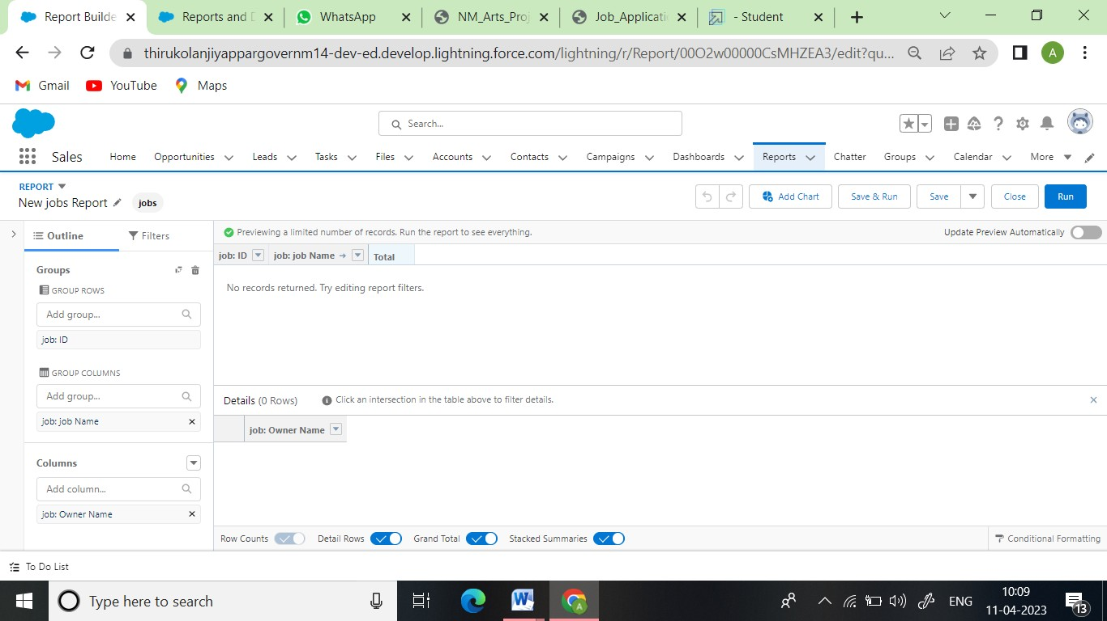

## Candidate

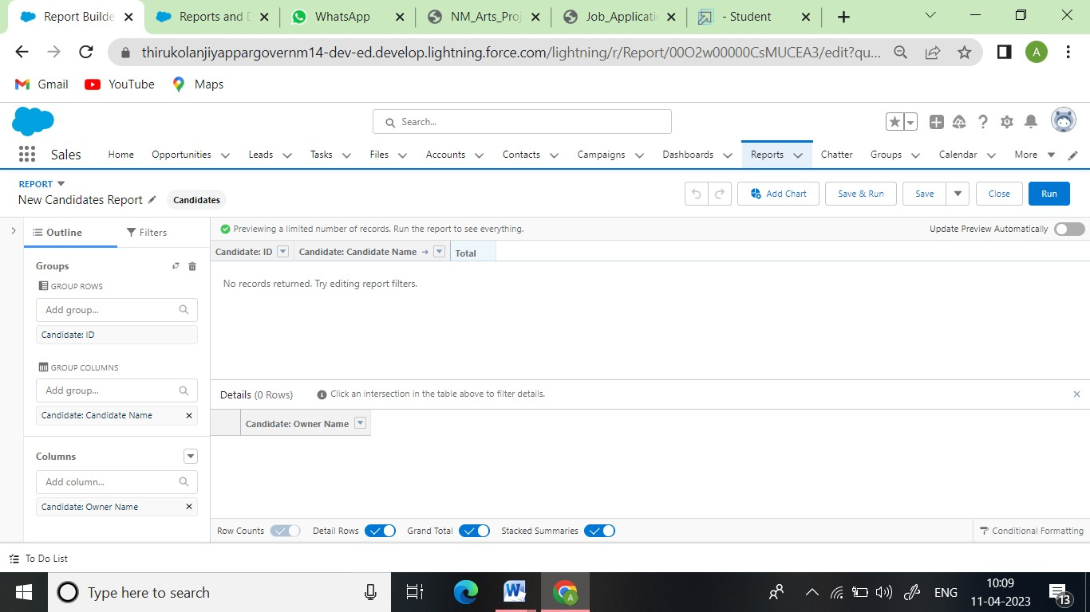

**Job Application**

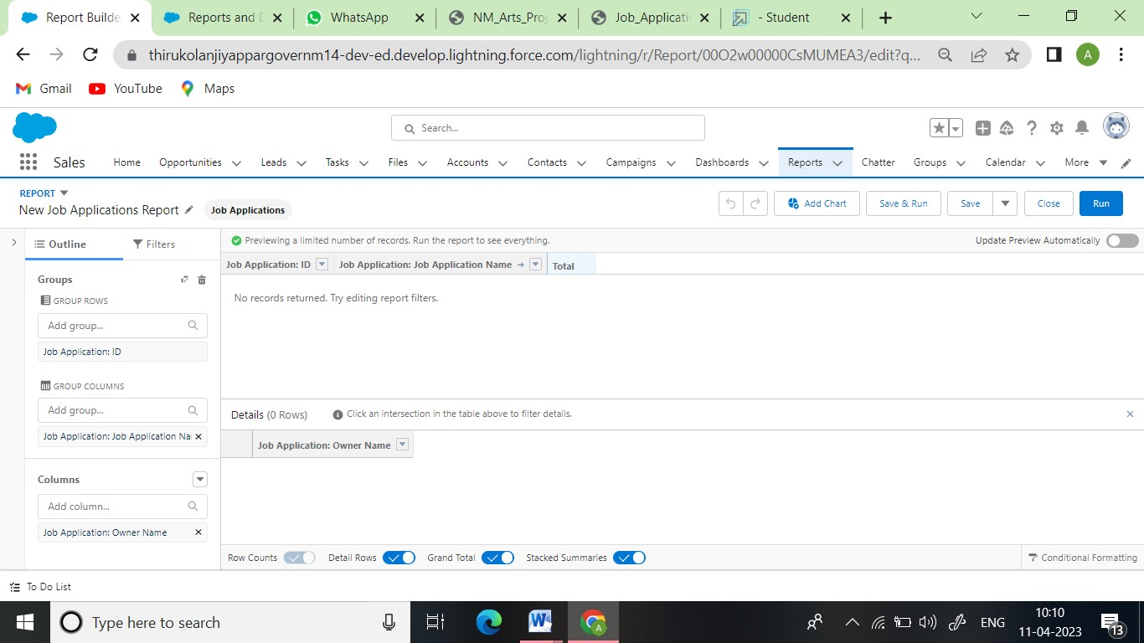

# Trailhead Profile Public URL

## Team Lead: K.IYYAPPAN

<https://trailblazer.me/id/ubscmaths>

## Team Member 1: T.VINOTH

<https://trailblazer.me/id/gdevil9>

## Team Member 2: A.SRIDHARAN

[https://trailblazer.me/id/srari8](https://trailblazer.me/id/dgovindhasamy)

## Team Member 3: G.DHINAKARN

<https://trailblazer.me/id/dgovindhasamy>

## ADVANTAGES & DISADVANTAGE

* 1. **ADVANTAGES**
     1. Time and cost-saving: ATS can significantly reduce the time and cost associated with recruiting.
     2. Improved candidate experience: With an ATS, candidates can apply online, receive immediate acknowledgment, and track their application's progress.
     3. Streamlined recruiting: An ATS helps recruiters manage the recruiting process more efficiently, reducing the administrative burden of tracking candidates, scheduling interviews, and managing communications.
     4. Data-driven decisions: With an ATS, recruiters can access recruitment metrics and reports, enabling them to make data-driven decisions and optimize the recruitment process.

## DIS ADVANTAGE

* + 1. Keyword-based screening
    2. Reduced personalization
    3. Technical issues
    4. Incompatibility with some candidates

## APPLICATIONS

* 1. Job Posting: The ability to create and post job openings to multiple job boards and social media platforms.
  2. Resume Parsing: The ability to extract relevant information from resumes and store it in a database.
  3. Candidate Management: The ability to manage candidate information and track their progress through the recruitment process.
  4. Communication Management: The ability to communicate with candidates and schedule interviews.
  5. Reporting and Analytics: The ability to generate reports and analytics on recruitment metrics such as time-to-hire, cost-per-hire, and source of hire.
  6. Compliance: The ability to comply with various laws and regulations related to hiring practices, such as the Equal Employment Opportunity Commission (EEOC) guidelines.

## CONCLUSION

In conclusion, ATS (Applicant Tracking System) applications are software tools that automate many of the manual tasks involved in recruiting.

The future scope of ATS looks promising, with advancements in AI and machine learning, candidate relationship management, integrated recruiting, mobile optimization, and data security.

Overall, ATS applications are an essential tool for recruiters and organizations that want to improve their recruitment process's efficiency and effectiveness. Recruiters need to understand both the advantages and limitations of ATS applications to make informed decisions about whether they are suitable for their recruitment needs.

## FUTURE SCOPE

* AI and Machine Learning: ATS will increasingly use AI and machine learning to improve resume screening, candidate matching, and decision-making. These technologies will help recruiters identify the most qualified candidates, predict the likelihood of a candidate accepting an offer, and analyse candidate data to optimize recruitment strategies.
* Candidate Relationship Management: ATS applications will evolve to focus more on candidate relationship management, providing recruiters with tools to engage candidates and build long-term relationships with them.
* Integrated Recruiting: ATS will integrate with other recruitment tools and platforms, such as video interviewing, candidate assessment, and on boarding systems, to provide a comprehensive recruitment solution.
* Mobile Optimization: With the rise of mobile technology, ATS applications will become more mobile-friendly, allowing candidates to apply and communicate with recruiters using their mobile devices.
* Data Security: With increasing concerns around data privacy and security, ATS will need to focus on data security and compliance, ensuring that candidate data is protected and meets regulatory requirements.

## Overall, the future of ATS applications looks promising, with advancements in AI and machine learning, candidate relationship management, integrated recruiting, mobile optimization, and data security. As the recruitment industry continues to evolve, ATS applications will play a critical role in helping recruiters attract and retain the best talent